**LAB # 07**

**Task # 1: Write a python program to implement the support vector machine on the built-in dataset from sklearn.datasets library (e.g. load_iris() ). Implement the following different kernels of SVM and compare the accuracy score.**

1. **Linear**
2. **Polynomial**
3. **Gaussian**

**Solution:**

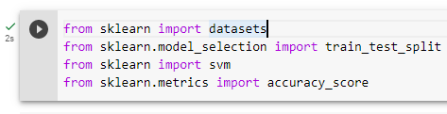



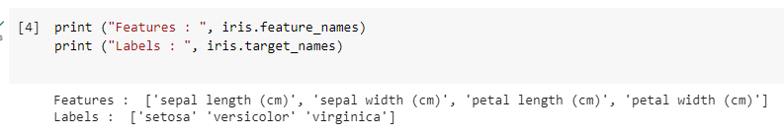

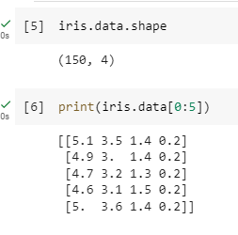

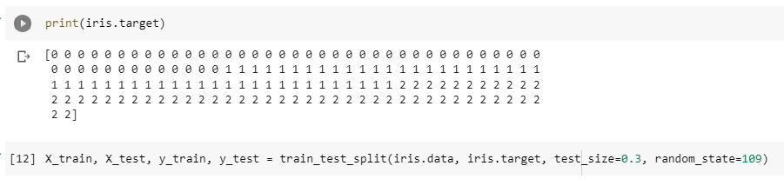

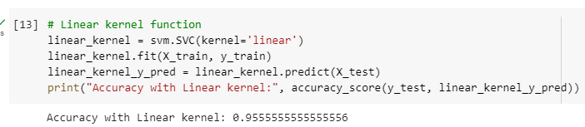

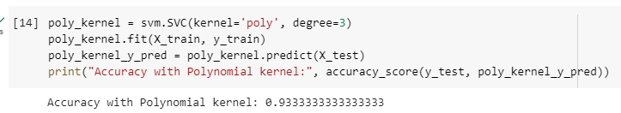

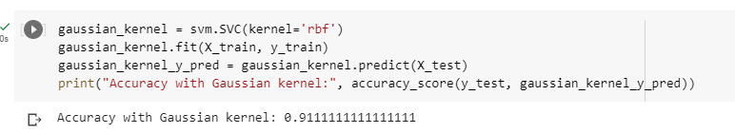

**Task # 2: Design a workflow with the help of Knime to implement the Support vector machine algorithm on any classification dataset.**

**Solution:**

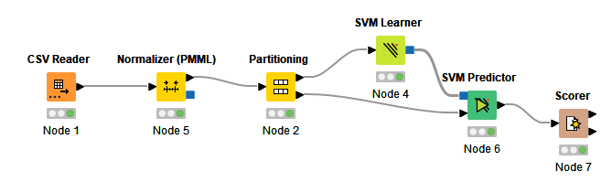

**Output:**

